**List of Figures**

**OPTIMIZATION MODEL FOR MULTI-PRODUCT MULTI-PERIOD MULTI-SUPPLIER RAW-MATERIAL SELECTION AND COMPOSITION, AND ORDER QUANTITY PROBLEM WITH MINUMUM ONE-YEAR ORDER QUANTITY CONTRACT**

# **List of figures**

Figure 1 One-year production planning and inventory control

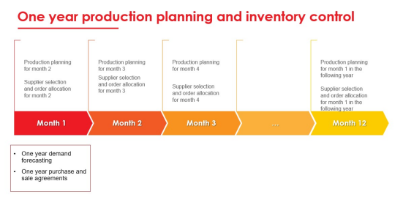

Figure 2 Decision proccess planning horizon

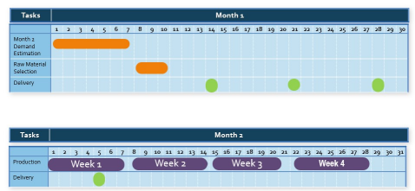

Figure 3 Illustration for inventory cost calculation

